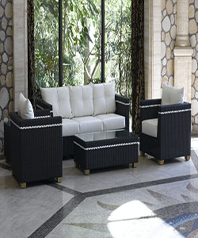

Tapered Leg Seating Collection with Pillows by inspire Durian sofa

$228.75

Availability: In stock

### Description

The light and fresh design, tapered legs, and oatmeal tweed upholstery of this seating collection create a stylish look that embraces vintage flair and modern living. Complete your living room decor with these chic seating options. Fabric, foam, wood, and plywood construction. Seat cushions are attached Back cushions and roll pillows are loose